**The Battle of Food Chains in Germany**

Applied Data Science Capstone Project by Oğuzcan Ünver

Contents

No table of contents entries found.

# Introduction

A View of Food Chains in Most Populated German Cities

An overview of key players and their positions is crucially important for any entrepreneur interested starting any business. Food is no exception.

## Cities

In this report, I gathered data from the following top 10 most populated German cities according to Wikipedia (https://en.wikipedia.org/wiki/List_of_cities_in_Germany_by_population);

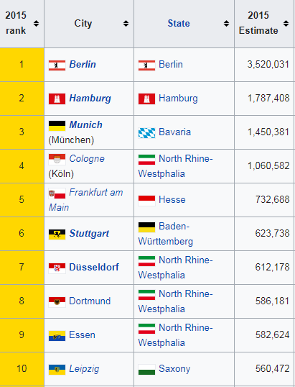

## Food Chains

I have gathered data for the following restaurants and food chains.



**McDonalds:** Most visited fast-food chain in Germany

McDonald's is an American fast food company, founded in 1940 as a restaurant operated by Richard and Maurice McDonald, in San Bernardino, California, United States. They rechristened their business as a hamburger stand, and later turned the company into a franchise, with the Golden Arches logo being introduced in 1953 at a location in Phoenix, Arizona. In 1955, Ray Kroc, a businessman, joined the company as a franchise agent and proceeded to purchase the chain from the McDonald brothers. McDonald's had its original headquarters in Oak Brook, Illinois, but moved its global headquarters to Chicago in early 2018

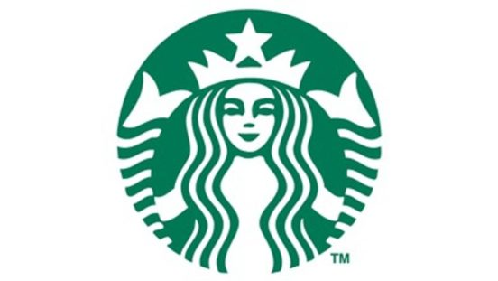

**Starbucks:** Most visited coffee shop in Germany

Starbucks Corporation is an American coffee company and coffeehouse chain. Starbucks was founded in Seattle, Washington in 1971. As of 2018, the company operates 28,218 locations worldwide.

Starbucks is considered the main representative of "second wave coffee", initially distinguishing itself from other coffee-serving venues in the US by taste, quality, and customer experience while popularizing darkly roasted coffee. Since the 2000s, third wave coffee makers have targeted quality-minded coffee drinkers with hand-made coffee based on lighter roasts, while Starbucks nowadays uses automated espresso machines for efficiency and safety reasons.



**Vapiano**: A popular middle-high class food chain

Vapiano is a German restaurant franchise company headquartered in Cologne. The chain's restaurants offer Italian food adhering to the fast-casual principle. Vapiano was established in 2002 in Hamburg. Its largest shareholder since 2011 is the private equity firm, Mayfair Vermögensverwaltung. Roughly one-third of the restaurants are operated by the company itself, but the majority are run by franchise partners or as joint ventures. In April 2017, Vapiano totaled 180 locations in 31 countries, including Australia, China, Egypt and the United States. For many years, the company was among the fastest-growing players in the industry.



**Extrablatt**: An alternative affordable casual food-chain

Cafe Extrablatt is a German company of system catering based in Emsdetten. In addition to more than 70 restaurants operated in the franchise system, they also have partnerships in other chains such as Cafe & Bar Celona and Woyton.

# Data

The data is gathered from Foursquare’s Places API. Only the main cities will be taken into consideration, and the numbers will be taken from the results coming from the API.

Data is gathered with the following API:

GET https://api.foursquare.com/v2/venues/search

With the following Parameters:

search_query = Will change according to the food chain considered

near = Will change for the city

radius = will be constant, 10000

intent= 'browse'

# Methodology

With the Foursquare API, following raw results were gathered.

Raw results are shown below.

|  |  |  |
| --- | --- | --- |
| City | Chain | Amount |
| Berlin | McDonalds | 50 |
| Berlin | Starbucks | 23 |
| Berlin | Vapiano | 8 |
| Berlin | Extrablatt | 1 |
| Hamburg | McDonalds | 40 |
| Hamburg | Starbucks | 11 |
| Hamburg | Vapiano | 5 |
| Hamburg | Extrablatt | 0 |
| Munich | McDonalds | 50 |
| Munich | Starbucks | 19 |
| Munich | Vapiano | 4 |
| Munich | Extrablatt | 0 |
| Cologne | McDonalds | 46 |
| Cologne | Starbucks | 5 |
| Cologne | Vapiano | 5 |
| Cologne | Extrablatt | 3 |
| Frankfurt | McDonalds | 48 |
| Frankfurt | Starbucks | 17 |
| Frankfurt | Vapiano | 3 |
| Frankfurt | Extrablatt | 2 |
| Stuttgart | McDonalds | 24 |
| Stuttgart | Starbucks | 6 |
| Stuttgart | Vapiano | 2 |
| Stuttgart | Extrablatt | 0 |
| Düsseldorf | McDonalds | 44 |
| Düsseldorf | Starbucks | 6 |
| Düsseldorf | Vapiano | 4 |
| Düsseldorf | Extrablatt | 3 |
| Dortmund | McDonalds | 15 |
| Dortmund | Starbucks | 4 |
| Dortmund | Vapiano | 2 |
| Dortmund | Extrablatt | 1 |
| Essen | McDonalds | 32 |
| Essen | Starbucks | 6 |
| Essen | Vapiano | 2 |
| Essen | Extrablatt | 7 |
| Leipzig | McDonalds | 22 |
| Leipzig | Starbucks | 2 |
| Leipzig | Vapiano | 1 |
| Leipzig | Extrablatt | 0 |

With the Data, Following Assumptions were made:

1. Numbers were taken as is. No extensive analysis was performed to check against Foursquare data.
2. 50 is the limit of Foursquare API, even higher number of chain restaurants would give this result. However, since the result 50 was got only 2 times, the real result was taken as is.

The following methodologies were used on the data

Data is converted to a pivot table with visualization. Pivot tables are an important part of data analysis, and they make visualization easier.

Rates of every chain was inspected agains each other.

As a machine learning method, correlation between some numbers are inspected.

# Results

The number of restaurants on a pivot are shown in the following table

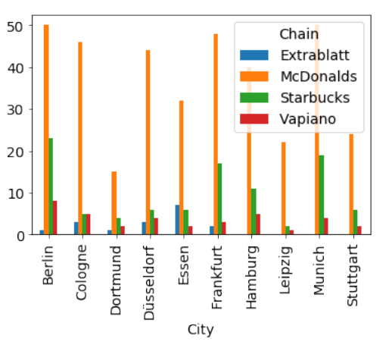

Since McDonalds is dominating the table, when it is removed, the results can be shown as the following

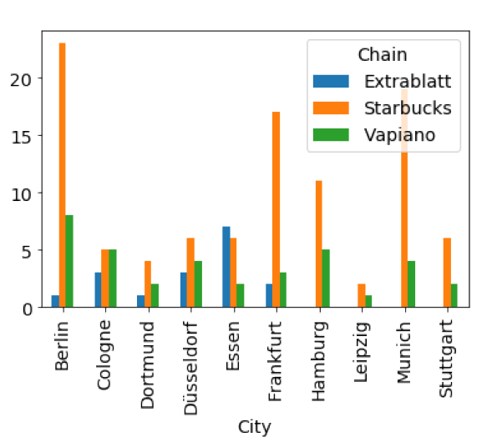

Vapiano is a middle-high scale restaurant, while Starbucks is a Coffee Chain. Their numbers were compared in order to understand if there are some relationships

Ratio of Vapiano vs Starbucks

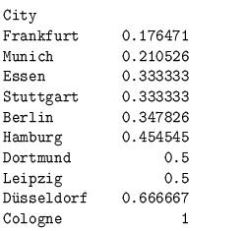

Ratio of Starbucks were also compared to McDonald go get some more insight

Ratio of McDonalds vs Starbucks

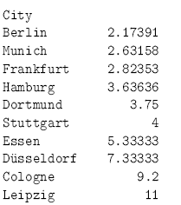

And Ratio of McDonald’s vs Vapianos

Ratio of McDonalds vs Vapiano

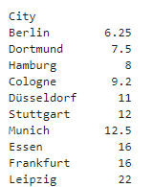

Lastly, any correlation between the number of chains in all the cities were investigated

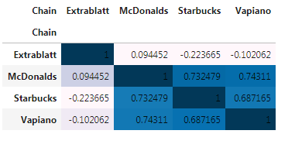

# Discussion

For anyone who wants to start a restaurant in Germany, first thing to notice might be the homogeneous nature of the German market. Other than Extrablatt, which does exist only in some western cities, there is a high correlation between the number of McDonald’s, Starbucks and Vapianos. But there are exceptions

The ratio of the number of McDonald’s vs Starbucks chains has an interesting nature. In the four largest German cities the number is as small as possible. It gets bigger, as the population of the city gets smaller. This can be interpreted as the penetration of McDonalds is better in more populated cities, then Starbucks.

When number of Vapianos vs number of Starbucks are investigated, it can be seen that it is smallest in Berlin, but there is no such correlation, so that it is not the case that larger the city smaller the number. This might mean that there is still more market opportunity for restaurants like Vapiano in these cities, such as Frankfurt, Munich.

# Conclusion

A lot of different data can be investigated when a new restaurant is going to be opened. Regarding Germany, the homogeneity of the country and well establishment of global chains should be taken into consideration.